**NUMPY**

NumPy (Numerical Python) is an open source library of python which is used extensively in data science. It provides multidimensional array and matrix data structures. Numpy makes computation of numerical values easier and more structural.

**Numpy Basics:**

Creating 2D array

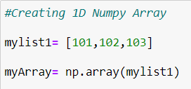

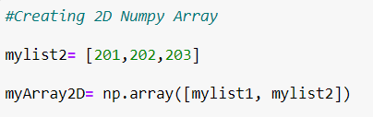

Finding dimensions of array using shape()

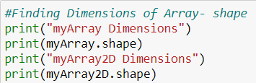

Finding the datatype of array using dtype()

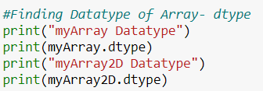

Creating and Initializing array using zeroes, ones, empty, identity and arange

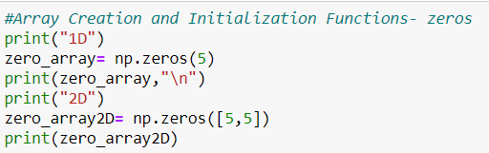

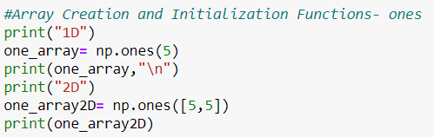

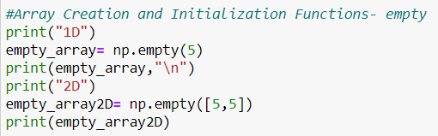

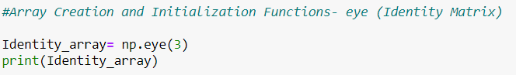

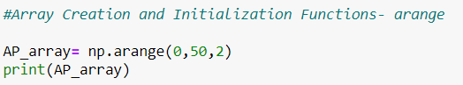

**Scalar Operations in Numpy:**

Scalar Array Multiplication



Exponential Multiplication

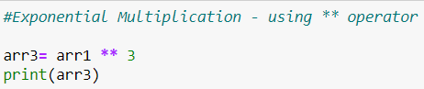

Scalar Subtraction

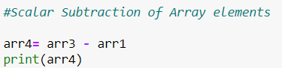

Scalar Division

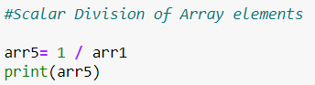

**Numpy Array Indexes:**

Accessing Individual Array Elements

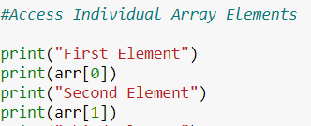

Slicing Array Indexes

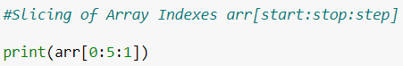

Updating Array using Slices

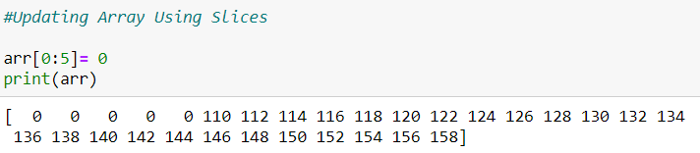

copy() function

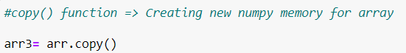

Accessing Rows

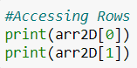

Accessing Elements of Array

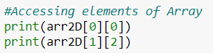

Slicing in 2D Array

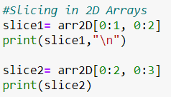

Using Loops to Change Index

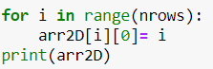

Accessing Rows using List of Index Values

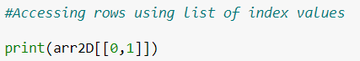

**Premium Array Operations:**

arange()

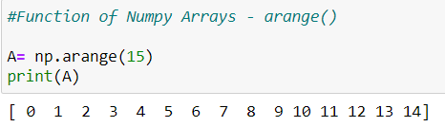

sqrt()

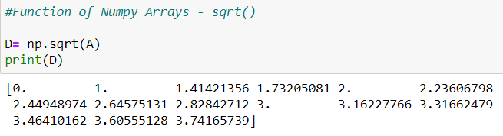

exp()

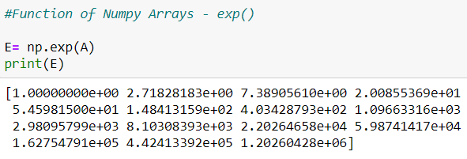

random()

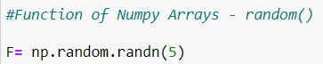

add()

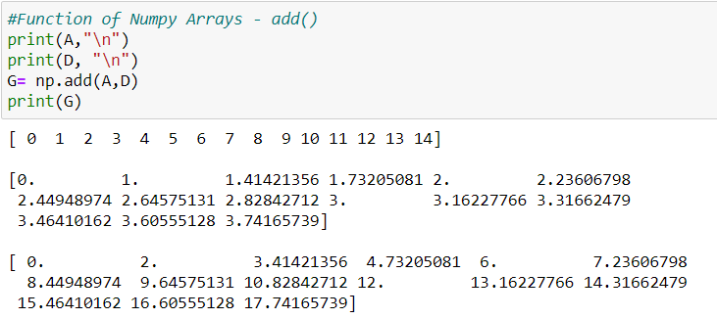

maximum()

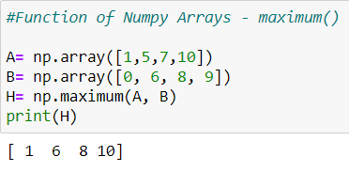

**Loading and Saving Array:**

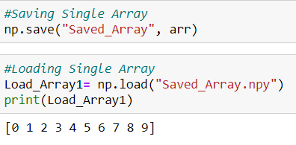

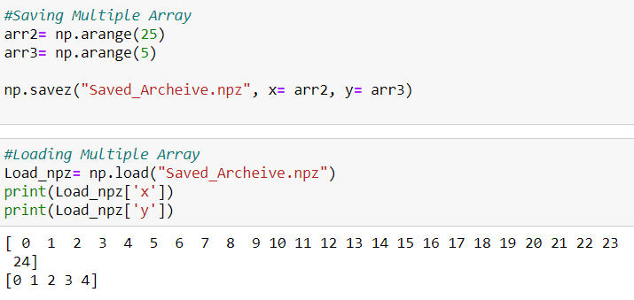

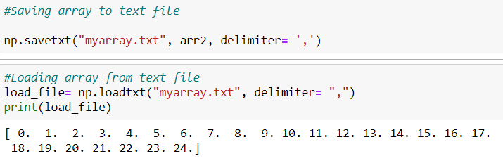

**Conditional Clauses and Boolean Operations:**

np.where()

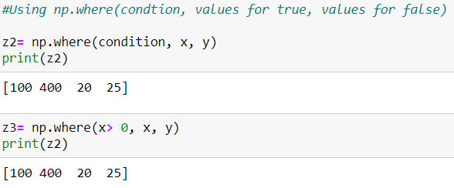

Sum

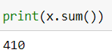

sum(0)

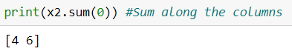

mean(), std(), var()

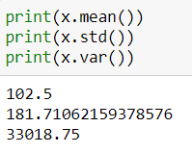

any(), all()

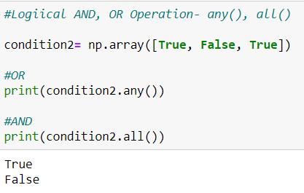

sort()

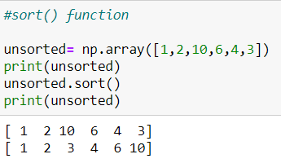

unique()

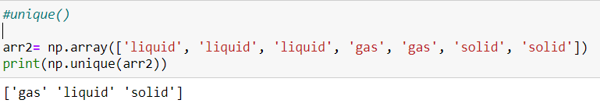

in1d()

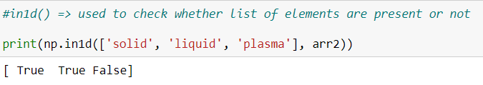

**Statistical Processing and Graphical Sketches:**

np.meshgrid()

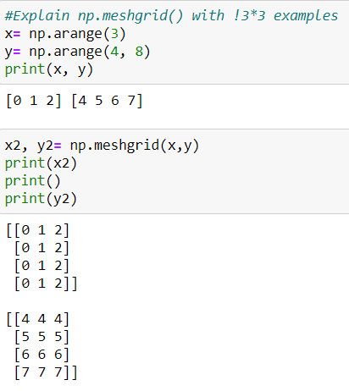

Linear function heatmap along with title and colorbar

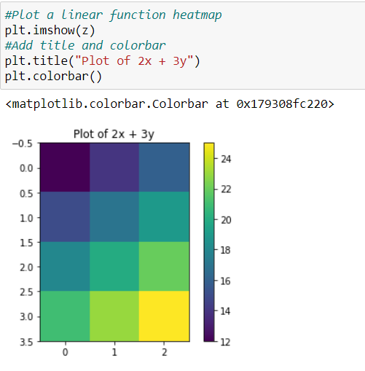

Cos function heatmap along with title and colorbar

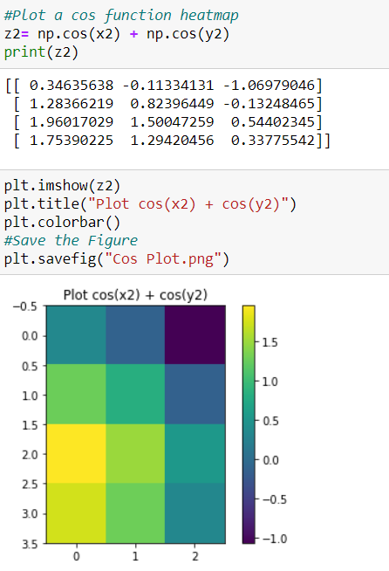

**PANDAS**

Pandas is helpful while working with tabular data. It is used for exploring, cleaning and processing given data where a data table is called a DataFrame. Pandas supports the integration with many file formats.

**Getting Started: Series**

Create a simple series variable

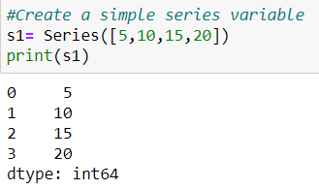

Create series from numpy

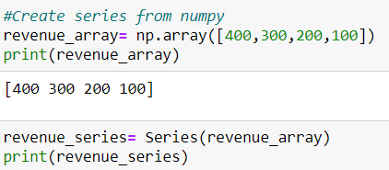

Create series with custom indexes

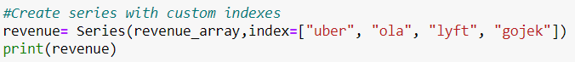

Filter a Series based on conditions



Check whether an element is in a series

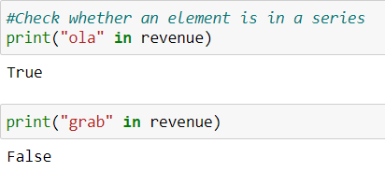

to_dict() function

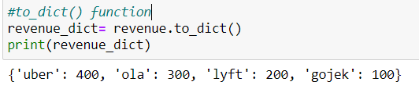

Addition of 2 series

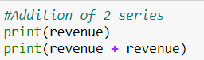

Assign names to a Series and its Index

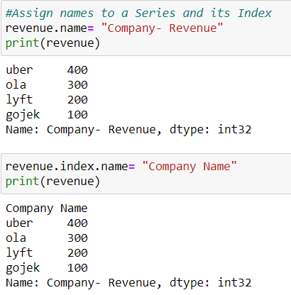

**Pandas DataFrame:**

* 2-Dimensional with 3 principal components- Rows, Columns and Values
* Similar to a table in excel sheet
* Labelled axes
* Size mutable

Create a DataFrame from clipboard

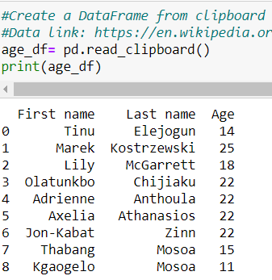

Display column names

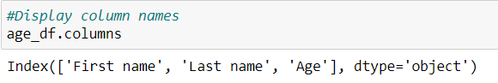

Access one or more columns





Create a column with NAN values

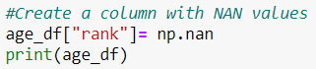

Head and Tail functions





Assign values to a dataframe using 1. Numpy 2. Series

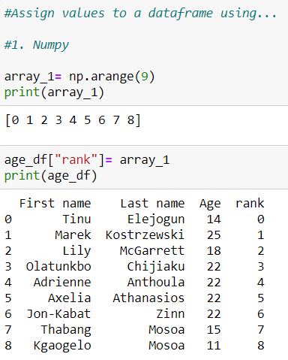

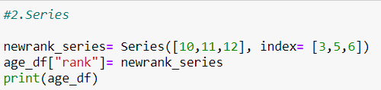

Delete a column

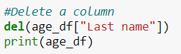

Convert dictionary to a dataframe

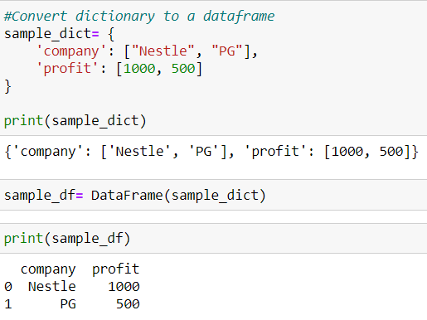

**Indexes in Pandas:**

Index Array

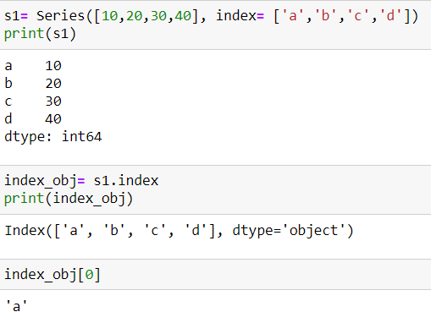

Negative Indexes

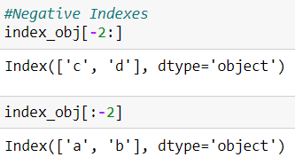

Range of Indexes

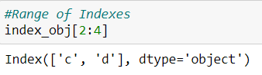

**Reindexing in Pandas Series and DataFrames:**

Reindexing in Series- reindex() method



Reindexing in Series- reindex() method with fill_value



Reindexing in Series- forwardfill

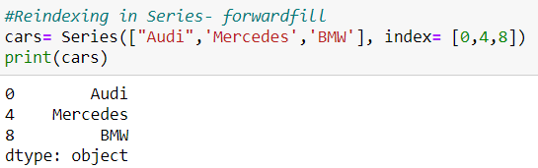

Reindexing in DataFrame



**Dropping Entries in Pandas Series and DataFrames:**

Drop values from Series

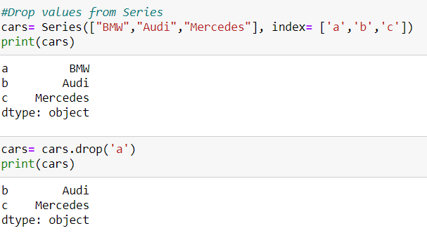

Drop Rows and Columns from DataFrame

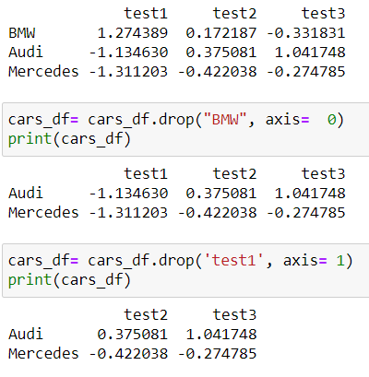

**Handling Null or NAN values in Pandas:**

Check for null using isnull()

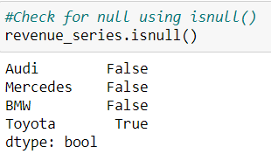

Series- dropna()



DataFrame- dropna()



DataFrame- dropna() with how parameter



DataFrame- dropna() along column



Dropna with thresh parameter

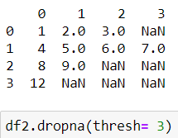

fillna() function





**Selecting and Modifying Entries in Pandas:**

Access single element of series



Access multiple elements of series



Using Numerical Indexes



Conditional Indexes



Accessing one or more column data from a DataFrame

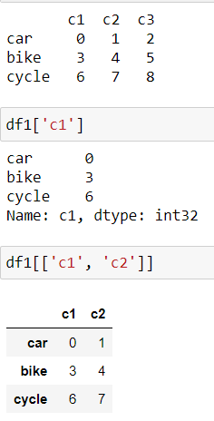

Boolean operation in DataFrame

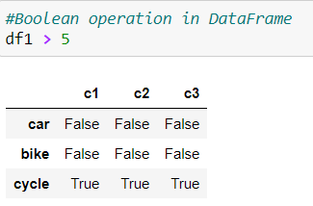

Using the DataFrame.loc[] attribute

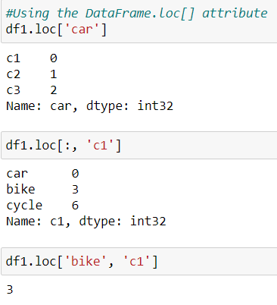

**Coordinate and Regulate Data in Pandas:**

Add 2 Series

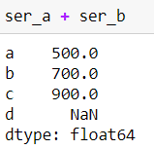

Add 2 DataFrames

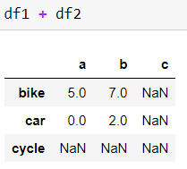

Use add() function

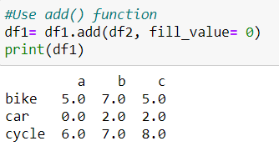

Subtract a series from a DataFrame

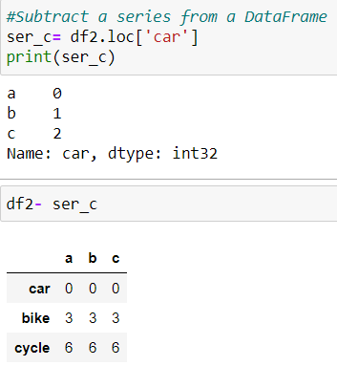

**Ranking and Sorting in Pandas Series:**

Sorting by Index



Sorting by Values



Ranking of Series



Interesting fact- Sorting uses ranking function

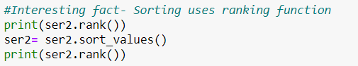

**Statistics and Graphs in Pandas DataFrame:**

sum() function

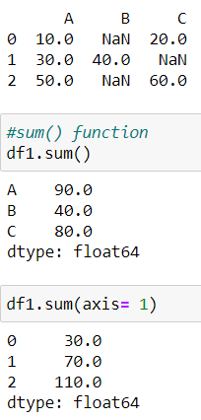

describe() function

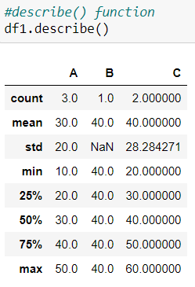

Graph of DataFrame

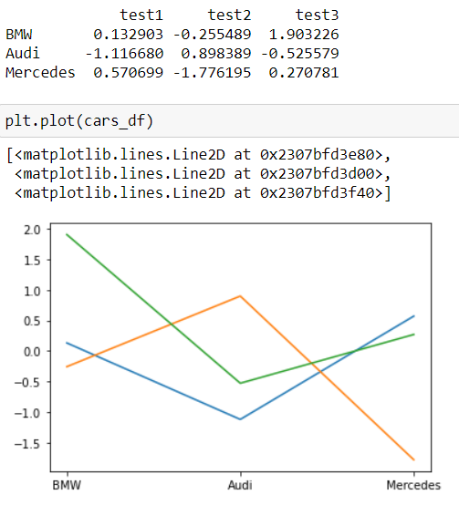

Unique elements of a Series

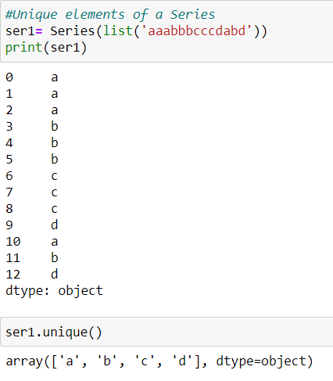

Frequency of elements in a Series

